Linux DSVM instructions

May 16, 2017

12:01 PM

This is an abbreviated version of what can be found on the [Azure documentation](https://azure.microsoft.com/en-us/documentation/articles/machine-learning-data-science-linux-dsvm-intro/) site.

(1) Provision a Linux Data Science Virtual Machine following the instructions at this link:

<https://azure.microsoft.com/en-us/documentation/articles/machine-learning-data-science-linux-dsvm-intro/>

-Once the DSVM is provisioned obtain the IP address by selecting the asset in the Azure Portal. You will find the IP address in the Overview section

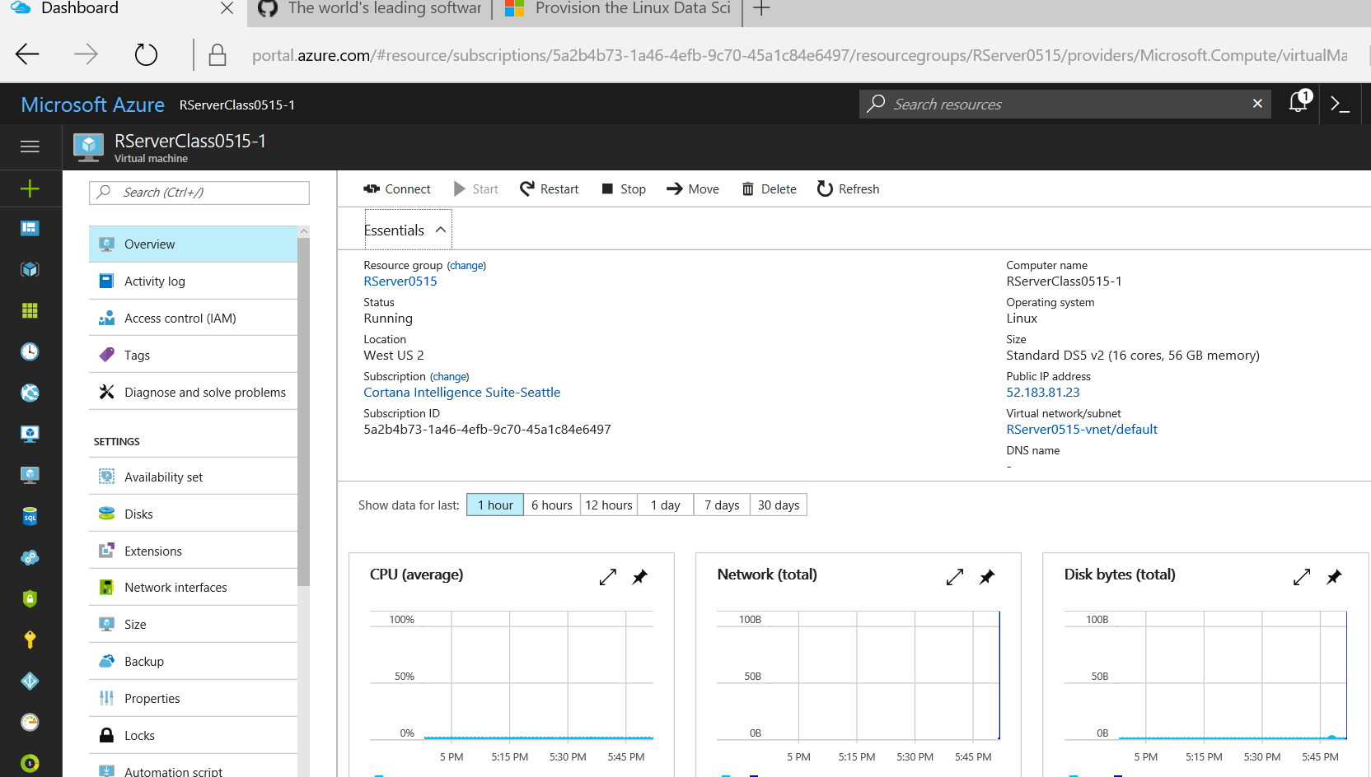

(2) Access the DSVM using either an SSH client like PuTTY <http://www.putty.org/> or the Linux graphical client X2GO ([X2Go client](http://wiki.x2go.org/doku.php/doc:installation:x2goclient)).

(3) Launch PuTTY to connect to the VM using the IP address, provide the admin and password you set up when you provisioned the VM.

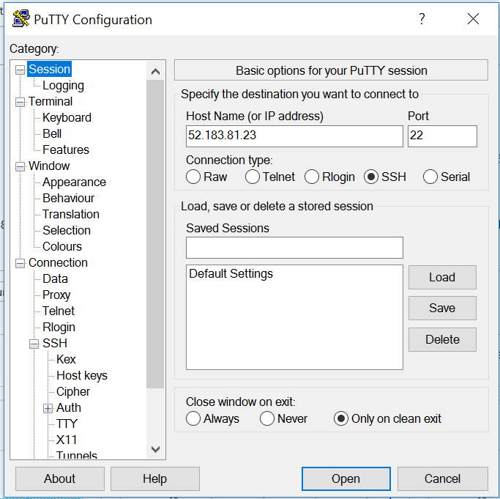

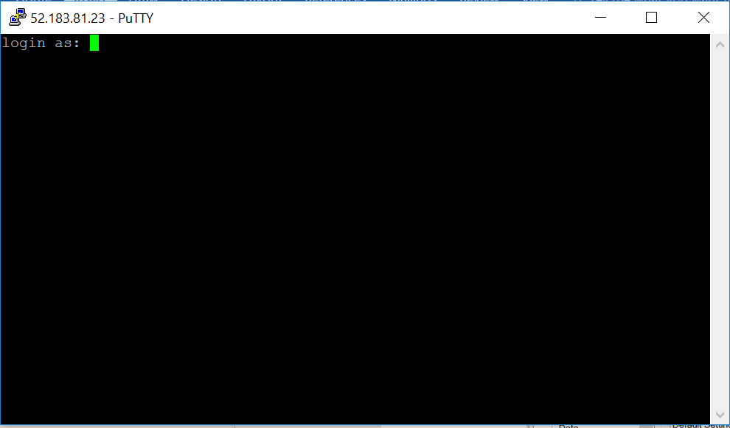

Log in as the root account by entering: **sudo su -**

Start rstudio-server by entering: **rstudio-server start**

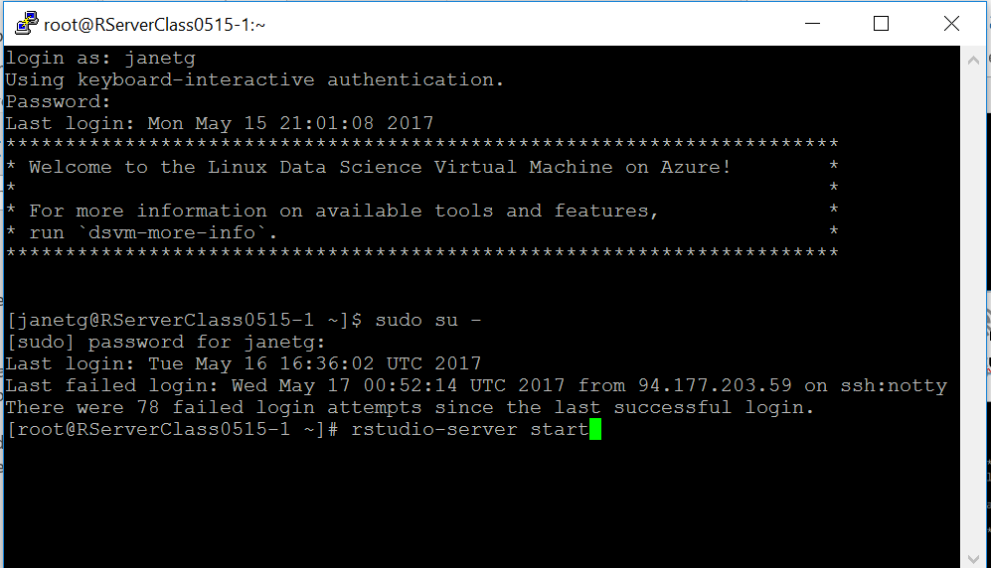

You can also use the X2GO client to connect to your Linux DSVM which will give you a graphical interface similar to Windows.

(4) JupyterHub should be running on the DSVM, to access it go to **https://<ip address>:8000** *Note: you may get an error message about a certificate error, "Continue" to the site anyway and log in*

Access RStudio server on port 8787, i.e.

http://<ip **address>:8787**